# APPENDIX C

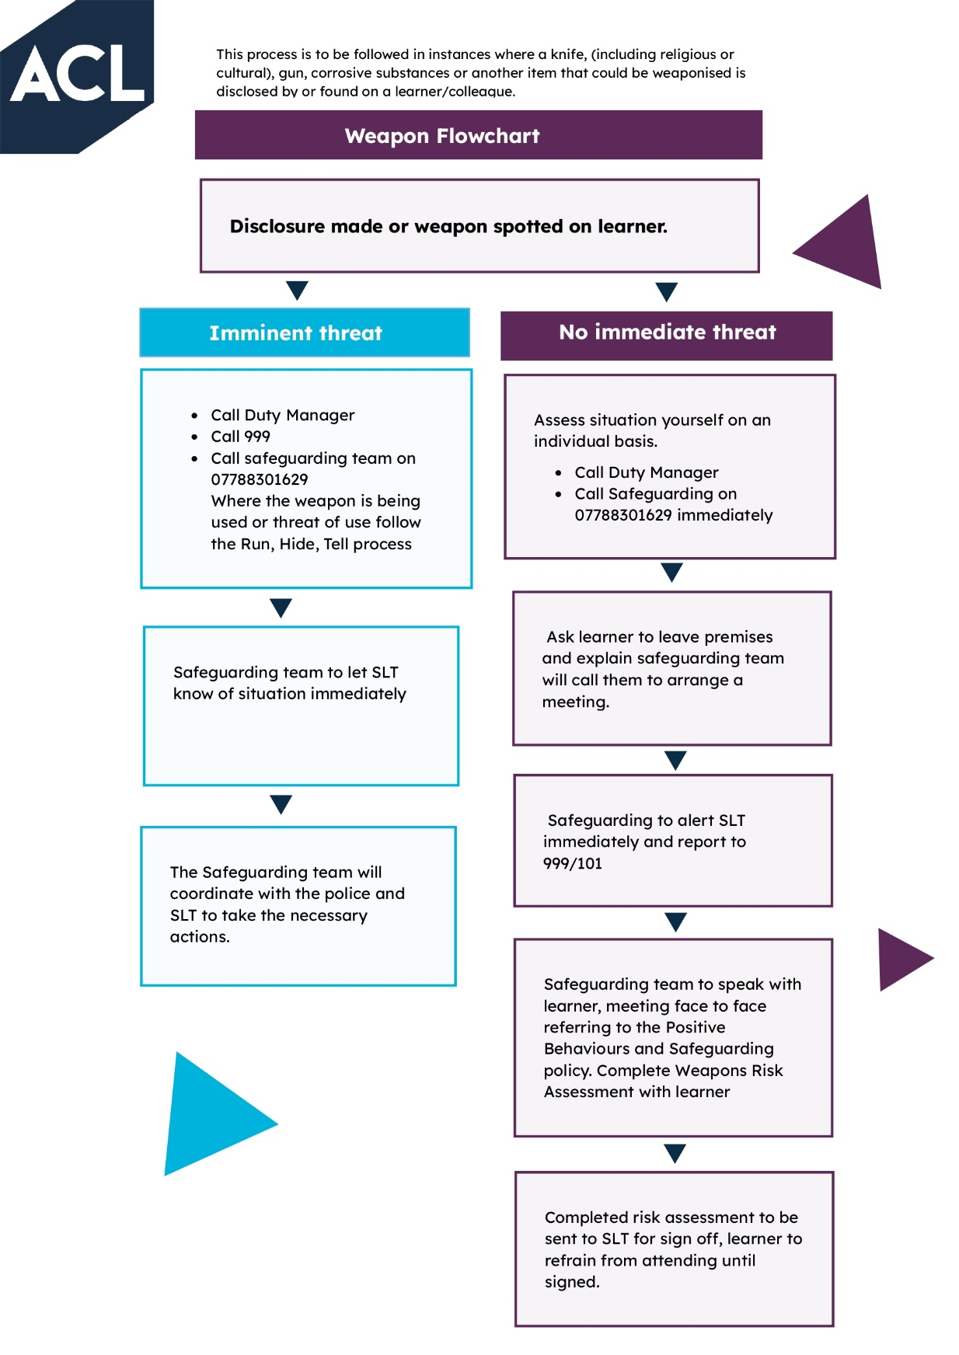

# 

# APPENDIX D



|  |  |  |  |  |  |  |  |  |
| --- | --- | --- | --- | --- | --- | --- | --- | --- |
| **Initial assessment following disclosure of carrying an article that could be weaponised.** | | | | | | | | |
| **Name:** | | | | | | | | |
| **Course applied for / attending:** | | | | | | | | |
| **Date of assessment:** | | | | | | | | |
| **Name of assessor:** | | | | | | | | |
| **Questions that will help better understand the applicants reasoning for carrying an offensive weapon inc Kirpan** | | | | | | | | |
| **Question** | | **Details provided**  Jack is an opportunist and could well be pre-occupied with meeting his own needs | | | | | | |
|  | | **Explanation** | **Risk** | **Management plan/mitigation** | | | **Risk remaining** | |
| **What is the reason for carrying this item?** | | *i.e. religious reasons* |  |  | | |  | |
| **Why is it essential to carry in college?** | | *i.e. religious reasons (see behaviours policy for 5Ks)* |  | *Could include locking away on site/not being in public areas?* | | |  | |
| **How is the item transported to and from college?** |  | | | |  |  | |  |

|  |  |
| --- | --- |
| **Decision/Outcome:** |  |

|  |  |  |
| --- | --- | --- |
| **Review Date:** | **Learners Name:** | **Name of Person carrying out RA,** |
|  | **Learners Signature:** | **Signature of person carrying out RA**: |
| **Date:** | **SLT** | **SLT member signature** |