Adult Community Learning

Fee and Charges Policy 2023-24

  - Control of Document: ACL Senior Leadership Team (SLT)
  - Responsibility Group: ACL Senior Leadership Team (SLT)
  - Date of Acceptance: 12.04.2022
  - Next review Date: 12.03.2024

Introduction

This policy outlines the fees and charges for Adult Community Learning (ACL) Essex for the 2023-24 academic year and is aligned to the strategic aims and priorities of the service.

Fees and charges relate to our learning and apprenticeship programmes, room hire, nurseries, pre-schools and salon treatments.

To ensure compliance with any mandatory changes imposed by the Education and Skills Funding Agency (ESFA), Essex County Council may be required to amend course fees within the academic year.

ACL’s primary source of income is from the funding received from the ESFA to deliver programmes of learning, to residents and businesses across Essex, including in some instances, its borders. In addition, learners pay fees towards the cost on some of the courses. Full cost and non-government funded provision may also be available.

ACL is on the Register of Apprenticeship Training Providers and able to deliver apprenticeship provision to both Levy and Non-Levy employers.

Content of this document:

- Types of Programme
- Eligibility
- Payments
- Financial Support
- Refunds and Cancellations
- Nursery and Preschool Fees
- Salon Treatments
- Room Hire

Annex. A provides further explanation of the terms, course levels and acronyms used in this document.
Annex. B provides the Eligibility Criteria for ESFA funded courses
Annex. C describes the Pound Plus Policy at ACL Essex.

Related policies:

Exams policy
Fitness to Learn Policy
Learner Attendance Policy
Positive Behaviours Policy
Discretionary Learner Support Fund Policy

Types of Programme

  - Accredited Learning (Courses which lead to a qualification)

  - Learners who are eligible for full funding from the ESFA will not be charged a fee for any aspect of the course, including exams, resources or awarding organisation registration and fees. In this scenario, ACL will draw down 100% of the fee allocation as set by the ESFA.
  - Learners who are eligible for co-funding as specified by the ESFA will be funded at a rate of 50% with a
maximum of the other 50% being paid by the learner or employer. In some cases and to support specific skills shortages in Essex the co-funding fee may be waived.

Learners who do not qualify for funding will pay 100% of the fee as set by the ESFA. In this instance, ACL draws down no funding from the ESFA – the learners pay the full fee.

Learners not eligible for funding may be able to take out an Advanced Learner Loan to cover the cost of a course at level 3 or above See 3.2.

Learners on accredited courses that are not funded by the ESFA (full fee) will be charged a course fee from £9.50 per hour plus the cost of qualification accreditation (exam fees).

The above fees apply to both classroom based and online courses.

Eligibility criteria for funding can be found in Annex B.

1.2 Non-accredited Learning (Courses which do not lead to a qualification)

- The standard fee rate per hour is £6.90
- For adults on certain benefits, and/or a gross annual income of less than £20,319 per annum the rate per hour is £3.45 (50% of the standard rate) see Annex. B. and C.
- For adults with learning difficulties (supported learning) the rate per hour is discounted to £3.60 with no further concessions, see Annex. C.
- Non-eligible learners as defined in the ESFA funding guidance will pay £9.50 per hour

The above fees apply to both classroom based and online courses.

Non-accredited courses that are not funded by the ESFA (full fee), including Courses for Enjoyment, will be charged at £9.50 per hour

1.3 Community engagement programmes and projects

In each academic year ACL will offer programmes and projects that meet a particular social or economic need within Essex. These courses will be free to participants. Programmes and projects may include, family and community-based learning, Social Prescribing and Get Back into Work.

In addition, ACL may deliver specially commissioned programmes and projects throughout the year which are funded by either Essex County Council or an external organisation or body. Courses are free to participants unless otherwise stated in the course information. Programmes and projects include: Mental Health Recovery and The Nightingale Care Bursary

See Annex. C.

1.4 Taster sessions

Throughout the year ACL may run short taster sessions of an hour or less for promotional and engagement purposes including ‘Learn at your Leisure’ programmes. These sessions will be free of charge to the participant.

1.5 Short courses (non-accredited)

Throughout the year ACL may run short introductory courses for promotional and engagement purposes. These will be new courses that meet a local priority or need, last no longer than 3 hours, and will cost between £10 and £15 to the participant with no concessions.
See Annex. C

1.6 Apprenticeships

No fee is charged to apprentices undertaking an apprenticeship programme. All employers must pay towards the cost of the apprenticeship training. Using an agreed formula, a negotiated price for each apprentice will be agreed between the employer and ACL prior to the commencement of the apprenticeship programme. The cost for each apprenticeship will be detailed in the Employer Agreement and Apprenticeship Commitment Statement, which is signed prior to the commencement of an apprenticeship programme. Pricing bands can be located on our website Employers - ACL Essex

Levy Paying Employers

Levy paying employers are those with an annual pay bill greater than £3m. These employers pay a government levy of 0.5% of their annual payroll. The levy is accessed via their Digital Apprenticeship account and is used to pay for the apprenticeship training. Levy paying employers who have exceeded their levy allocation are still able to access apprenticeship funding and will pay 5% of the agreed cost for any new apprentice not covered by their levy - the remaining 95% will be funded by the ESFA.

Non-Levy Paying Employers

Non-levy employers are those who have an annual pay bill of less than £3m. These employers will contribute to the cost and pay a co-investment fee. This will be 5% of the negotiated price of each apprenticeship. The remaining 95% will be funded by the ESFA. Funding is secured through the Digital Apprenticeship Service. Availability of funding for non-levy employers is subject to the amount made available from the ESFA.

Levy Transfers

Levy-paying employers can transfer a maximum amount of 25% of their annual funds. They can make transfers from their apprenticeship account to as many employers as they choose. Transferred funds will be used to pay for the training and assessment cost of the apprenticeships agreed with the receiving employer and ACL. The Essex Levy Transfer Service run by Essex County Council and ACL Essex can facilitate the transfer of levy funds.

Additional qualifications within an apprenticeship

Where an additional non-mandatory qualification is requested and delivered as part of the apprenticeship the employer shall be liable for any additional costs. This will be agreed prior to commencement of the programme.

1.7 Bespoke courses for employers, schools and charities

Bespoke courses will be costed and charged from £100 per hour. Accreditation costs (e.g., registration or exam fees) are not included and may incur an additional charge. A Bespoke Course Agreement will be completed by ACL and the organisation, and a 10% non-refundable deposit will be required to secure the course booking. Full payment of the course will be required 14 days before the planned start date. Where the course is due to be delivered within 14 days of booking, full payment will be required at the time of booking.

A reduced rate of from £85 per hour will be applied to charities and volunteer groups.
See Annex. C

Refreshments and lunch can be arranged at additional cost.

1.8 ESOL (English for Speakers of Other Languages)

To promote greater participation in learning a reduced rate of £300 will be applied for ESOL learners who enrol on and study both the reading and writing components of the course at the same time.

See Annex. C.

1.9 Courses for Enjoyment

These courses enable learners to continue developing and exploring their creative skills in a relaxed and sociable environment. without the need to follow a prescribed curriculum or undertake a qualification.

Eligibility

To receive funding from the ESFA for courses, learners will need to satisfy the eligibility criteria as specified in the ESFA funding rules. See Annex B.

Due to the recent devolution of AEB funding in some areas of the UK, learners that reside in postcodes within the devolved areas are no longer eligible for the ESFA funding that ACL Essex operates under (this does not include apprenticeships). In these instances, we will signpost learners to the provision that they are eligible to access. If they prefer to undertake a course with ACL Essex, full fee charges will apply.

Payments

For those unable to make a payment in full at the time of enrolment, several payment options are available.
3.1 Direct Debits and Instalment Payments
Direct Debits

Direct debits are available on courses with a fee of £100 and above. Learners must complete a Direct Debit Mandate and pay the 35% deposit at the time of enrolment. The balance is paid on a monthly basis by direct debit over the duration of the course. The number of instalments depends on the length of the course.
Apprenticeship co-investment payments can be made by direct debit. The monthly amount will be agreed with the employer prior to the apprenticeship start date. Any outstanding balance will need to be settled prior to the apprentices End Point Assessment.
Instalment Payments
In exceptional circumstances e.g. hardship, an individual may request to pay for their course in instalments. An affordable instalment plan will be agreed prior to the start date of the course. This request will be approved by the relevant Centre Lead. The course fee must be paid in full prior to its end date
3.2 Advanced Learner Loans

Where a learner is not eligible for ESFA funding, an Advanced Learner Loan may be applied for. Eligibility does not depend on an individual’s income and there are no credit checks. The course undertaken must be at level 3 or above to qualify. The government website has information on how to apply.

3.3 Missed Payments or Outstanding Fees
If an instalment or direct debit payment is missed, learners will not be allowed to attend their course again until payments are up to date.
If an apprenticeship payment is missed, the apprentice could be removed from their programme.
Learners deciding not to return to the course and who have paid by direct debit, advanced learner loan or instalment payment arrangements, are still liable for payment of the full course fees.
Fees that remain outstanding will be invoiced to learners or employers by ECC finance.
If a learner does not clear their outstanding fees, they will not be able to enrol on another course with ACL until the fee has been fully paid.

ACL will seek to recover unpaid fees through ECC debt recovery.

Financial Support

Financial assistance could be available for childcare and transport costs or to provide IT equipment and books for study. To be eligible, learners must have either a gross household income of less than £35,000k per annum (not including house shares, or where rent is paid separately) or a personal gross income of less than £20,319 per annum. Full details can be found in the Financial Support Guidance document on our website or on request.

See Annex. B.

Refunds and Cancellations (courses and apprenticeships)
5.1 Learner Refunds
A refund will be issued where a learner cancels their enrolment at least 14 days before the course start date. An administration fee of £30 applies which will not be refunded.
It is not the policy of ACL Essex to refund fees automatically when a change in circumstances prevents or discourages a learner from continuing with a particular class. Refund of course fees will only be made in exceptional circumstances, such as ill health. Any request for a refund is required in writing and should be directed to the Senior Leadership Team for approval. If a written request is not received, no consideration will be made for issuing a refund. If a refund is agreed, it will be pro-rata based and subject to deduction of a £30 administration fee. Any ancillary costs such as exam fees will not be refunded.
5.2 Course Refunds
If ACL cancels a course before it is due to start, in the first instance the learner will be offered an alternative programme. Where no suitable alternative is available the learner can choose to have a credit for the full amount added to their ACL account or receive a full refund.

In the unlikely event that ACL has to cancel a course after it has started and no suitable alternative is available, the learner can choose to have a pro-rata credit added to their ACL account or, receive a pro-rata refund.

If a course needs to be deferred or changed and the learner can no longer attend, in the first instance the learner will be offered an alternative programme. Where the course has not yet started and no suitable alternative is available, the learner can choose to have a credit for the full amount added to their ACL account or receive a full refund. Where the course is in progress and no suitable alternative is available, the learner can choose to have a pro-rata credit added to their ACL account or, receive a pro-rata refund.

In the event that a credit refund is given, and the learner wishes to book onto the same, or similar course that starts in the next academic year, ACL may, honour the course fee applied to the cancelled, changed or deferred course. Credit refunds must be spent within 24months of their issue date.

When a learner has paid their course fees and is not able to continue with their learning due to one or more reasons described in the Fitness to Learn policy a full refund will be given.

If a learner is excluded from their course for one of the reasons described in the Positive Behaviours Policy, no refund will be given and they will not be eligible to apply for another course at ACL.
5.3 Apprenticeship Refunds
Levy Paying Employers
If the apprentice leaves their employer prior to completion of their programme, payments will cease at the point they are removed from the DAS (digital apprenticeship service) account.
Non-Levy Paying Employers
If the apprentice leaves their employer prior to completion of their programme ACL will calculate the amount of co-investment received by the employer to the date the apprentice ceased employment. ACL will then, where required, invoice the employer for any underpayment of the co-investment or credit back any overpayment that ACL has received. Any underpayment is paid for by the employer and not the apprentice.
5.4 Bespoke courses for employers’ and charities’ refunds

Where an employer or charity cancels planned provision, a sliding scale of charges will be applied. Any refund due will be credited back to the employer within 14 days.
Cancellation period | Charge
14 working days or more prior to start of the planned course | 10%
Between 7 and 13 working days prior to start of the planned course | 50%
Between 48hrs and 6 working days prior to start of the planned course | 75%
Less than 48hrs notice | 100%

In the unlikely event that ACL needs to cancel or defer planned provision please see section 5.2.

5.5 Accredited Course Withdrawals

Learners who withdraw from their course without completing, and who have received funding to cover all or part of their accredited course fees will be liable to pay a fee of 10% of the whole qualification cost

5.6 Apprenticeship Withdrawals

If an apprentice that was sourced and placed through ACL withdraws (or is withdrawn by their employer) from their apprenticeship but continues working with the same employer there will be charge of £750 to cover recruitment and set up fees. The charge will also be applied if the apprentice leaves the employer but is then found to have been re-employed within three months of their leaving date. This charge is paid for by the employer and not the apprentice.

If the apprentice was an existing employee at the start of their apprenticeship and withdraws (or is withdrawn by their employer) from their apprenticeship but continues working with the same employer there will be a charge of £250 to cover set up fees. This charge is paid for by the employer and not the apprentice.

Course Transfers

Course transfers are limited to one per enrolment within the first week of the course start date. Any additional transfers will be subject to a £25.00 administration charge per transfer

Nursery and Pre-school Fees

The ACL nursery and pre-school facilities are available to anyone in Essex requiring childcare. Priority is given to the children of ACL learners. Each setting is different and prices are aligned to the facilities available at each in line with current market rates.

Nursery vouchers are accepted.

Up to date nursery and pre-school fees can be found on the ACL website.

Salon Treatments

ACL has training salon facilities across the county. Treatments are carried out by learners under the guidance and supervision of their tutor.

The price list for the ACL training salons can be found on the ACL website. Payment will be made directly to the salon at the time of the treatment.

Beauty treatments
Hair Salons

Room Hire
ACL has a number of facilities available for hire.

Standard Classroom (up to 16 people)
- Not for profit/Charity £17.00 per hour
- Other £22.00 per hour

Large Classroom (up to 30 people)
- Not for profit/Charity £22.00 per hour
- Other £25.00 per hour

Specialist Classroom e.g. I.T. Suite or Pottery Studio
- All hiring £34.00 per hour

Small Hall (Brentwood)
- Not for profit/Charity £22.00 per hour
- Other £25.00 per hour

Standard Hall (Colchester, Basildon)
- Not for profit/Charity £22.00 per hour
- Commercial/ private £34.00 per hour

Grand Hall (Brentwood) and Digital Hub (Colchester)
- Not for profit/Charity £34.00 per hour.
- Other £50 per hour

An additional cost of £32 per hour will be incurred if Technician and or out of hours site staff support is required. This will be confirmed at time of booking.

Catering and refreshments can be supplied if requested at time of booking. Please note that should catering or refreshments be ordered the cost of the overall package, including room hire, will be subject to VAT at the standard rate.

A Room Hire form will be completed by ACL and the hirer; a 10% non-refundable deposit will be required to secure the room booking. Full payment will be required 14 days before the planned start date. Where the room hire is required within 14 days of booking, full payment will be required at the time of booking.

If a hirer cancels their room(s) booking, a sliding scale of charges will be applied. Any refund due will be credited back to the hirer within 14 days.
Cancellation period | Charge
14 working days or more prior to hire date | 10%
Between 7 and 13 working days prior to hire date | 50%
Between 48hrs and 6 working days prior to start of the planned course | 75%
Less than 48hrs notice | 100%

Internal ECC hirers will be subject to the above cancellation charges. Method of payment will be by journal transfer.

In the unlikely event that ACL needs to cancel a room booking a full refund will be given

Annex A. Explanation of terms and acronyms

ESFA
The Education and Skills Funding Agency is the government department responsible for administering the distribution of funding to post-16 Education providers.
SLT
The Senior Leadership Team at ACL: Principal, Vice Principal Curriculum and Learning, Vice Principal Quality and Compliance, Business Operations Manager and Commercial Manager.

Tuition Fee Types

There are four different fee types; fully funded, co-funded, self-funded & full fee. This is subject to availability of ACL’s funding allocation.
1. Fully funded Fees
Where a learner meets the criteria to have their course fully-funded by the Government, or other funding organisations, no fee will be charged for tuition, examinations, registration or anything else that is necessary for the learner to achieve their course, though ACL reserves the right to charge a learner for any extracurricular activities or for materials and services that are not specifically required in order for them to achieve this. Full eligibility criteria can be found in Annex B.
2. Co-funded Fees
Where a learner meets the criteria to have their course co-funded by the Government a co-funded fee will be charged at the beginning of their course. This fee will include:
- Tuition Fees for all programme elements
- Registration, Examination and Assessment Fees where applicable
- Additional consumables and protective clothing fees may be payable as a requirement of the course (Ancillary fees)

Full eligibility criteria can be found in Annex B.

3. Self-funded & Full Fee

Where a learner is not eligible to receive any funding towards a course or the course does not attract government funding.

A discount may be applied to some accredited courses in priority sectors e.g. health and social care.

Community Engagement Programmes and Projects
Social Prescribing
Social prescribing is linking patients using health services with sources of support within the community such as learning organisations. It provides GPs and other health care providers with a non-medical referral option that can operate alongside existing treatments to improve health and wellbeing. Other professionals who are working with clients, who are not accessing health services, but may require wellbeing support can also refer individuals e.g. DWP, social workers, CAB.

Family Learning
Courses to support families in an array of subjects including maths, English, digital, family wellbeing, emotional wellbeing and parenting. All courses are run in conjunction with local primary schools and early years settings.
Employability
These courses are designed for people who are looking for employment. They support the skills needed to search and apply for new opportunities, write a CV and application form, undertake interviews, prepare presentations, and make use of transferrable skills.
Qualification Levels
Entry Level courses are for people without qualifications and are designed to improve reading, writing and IT skills. Each entry level qualification is available at three sub-levels - 1, 2 and 3. Entry level 3 is the most difficult.
Level 1 courses help you gain skills that will help you get a job or move onto an intermediate qualification. These courses provide an introduction to a subject area and include GCSEs at grades 3, 2, 1 or grades D, E, F, G
Level 2 courses are designed for new entrants to the subject area and or workplace. They include Intermediate Apprenticeships and GCSEs at grades 9, 8, 7, 6, 5, 4 or grades A*, A, B, C
Level 3 courses assume prior achievement at level 2 or previous study/work in relevant subject area. If vocational some level of responsibility within the workplace may be required. Courses at level 3 include Advanced Apprenticeships and Access to Higher Education Diplomas
Levels 4 and 5 courses are designed for those already working within a particular sector and looking to develop their skills up to degree level. If the qualification is vocational some level or management or seniority within the workplace may be required. Courses at levels 4 and 5 include Higher Apprenticeships and NVQs
Community Learning
The purpose of Community Learning is to develop the skills, confidence, motivation, and resilience of adults of different ages and backgrounds in order to:
- progress towards formal learning or employment and/or
- improve their health and well-being, including mental health and/or
- develop stronger communities
Community Learning Courses are delivered under the following seven delivery strands:
- Engaging and/or building confidence
- Preparation for further learning
- Preparation for employment
- Improving essential skills (English, including English for Speakers of Other Languages, maths and digital provision)
- Equipping parents/carers to support children’s learning
- Health and well-being
- Developing stronger communities

Annex B. Eligibility
All learners must meet the residency criteria to be eligible for funding.
A learner must be one of the following:
- A UK national or other person with right of abode* AND have been ordinarily resident in the UK for at least the last 3 years
- An EEA national in the UK must have obtained either pre-settled or settled status under the EU Settlement Scheme# AND lived in the EEA (including the UK) for at least the last 3 years
- Other non-UK nationals with eligible immigration status (see additional guidance)

Evidence of eligibility will be collected and made available for ESFA audit
*Persons with the right of abode have the right to live and work in the UK. All British citizens have the right to abode.
#Evidence of settled status can be either a copy of the settled status decision letter or the learner can provide a ‘share code’ so the settled status can be viewed on GOV.UK
ACL cannot use government funds for an individual if any of the below apply:
- They are in the United Kingdom illegally
- They have overstayed their immigration or visitor visa
- Their immigration status restricts access to government funding
- They are on another fully funded fulltime course

Full ESFA funding guidance can be found here https://www.gov.uk/government/publications/adult-education-budget-aeb-funding-rules-2023-to-2024/esfa-funded-adult-education-budget-funding-rules-2023-to-2024

Eligible Benefits
For funding purposes, we define a learner as in receipt of benefits if one or more of the following apply, they:
- receive Jobseeker’s Allowance (JSA), including those receiving National Insurance credits only
- receive Employment and Support Allowance (ESA)
- receive Universal Credit (UC), and their take-home pay as recorded on their UC statement (disregarding UC payments and other benefits) is less than £617 a month (learner is sole adult in their benefit claim) or £988 a month (learner has a joint benefit claim with their partner)​
- are released on temporary licence, studying outside a prison environment, and not funded by the Ministry of Justice
ACL may also use their discretion to fully fund other learners if both of the following apply. The learner:
- receives other state benefits excluding child benefit and their take home pay (disregarding benefits) is less than £617 a month (learner is sole adult in their benefit claim) or £988 a month (learner has a joint benefit claim with their partner), and
- wants to be employed, or progress into more sustainable employment, and their take-home pay (disregarding UC payments and other benefits) is less than £617 a month (learner is sole adult in their benefit claim) or £988 a month (learner has a joint benefit claim with their partner), and you are satisfied identified learning is directly relevant to their employment prospects and the local labour market needs.​ See Annex. C.
Low wage eligibility
Learners who are employed or self-employed and earn less than £20,319 annual gross salary (gross profit for self-employed) are entitled to full funding for an accredited course regardless of how many hours they work. See charts below for details of eligible courses. Evidence of low wage will be required e.g., a wage slip, current Universal Credit statement.

The level of government contribution for ESFA funded Accredited Courses
The following charts summarise when an adult learner will receive a fully funded place on a course or a co-funded place. These charts are from the ESFA website
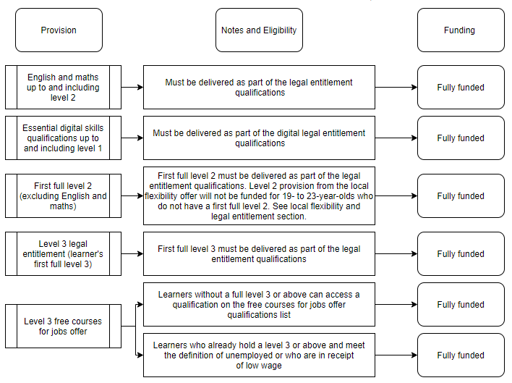
Chart 1: 19- to 23-year-olds
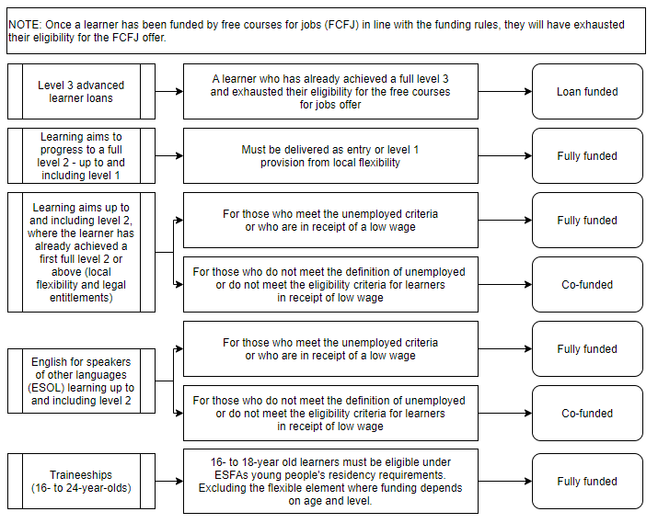

Chart 2: 24 plus
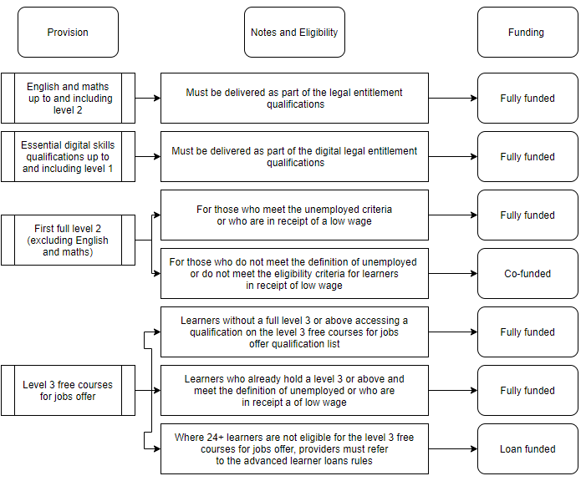
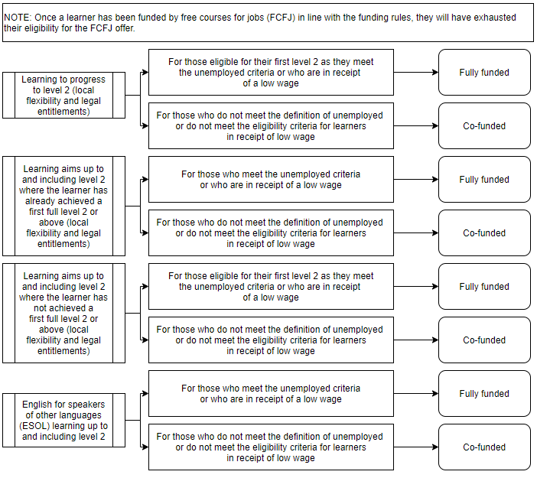

Annexe C. Pound Plus

Pound Plus refers to the generation of additional income over and above the core grant funding providers receive from the Education & Skills Funding Agency (ESFA) through the Adult Education Budget. Pound Plus describes how learning providers demonstrate that they are maximising the value of the public investment into adult education. This can be achieved by either generating additional income or greater efficiency of educational delivery by providing access to learning to more individuals at no extra cost.
Any fees collected by ACL Essex will be used to help support the delivery of courses within deprived areas of the community or to reduce barriers to learning for disadvantaged residents, for example those listed within Annex. A. under Community Engagement Programmes and Projects
In addition to core grant funding ACL Essex generates additional income or cost saving in the following ways by:
- charging a tuition fee with concessions for those on a low income or benefits or with learning disabilities.
- having an evidence led approach to curriculum planning to ensure that courses meet local priorities and enable progression.
- efficient and effective planning to ensure maximum impact from learning is achieved and that the curriculum avoids duplication
- using a blended and distance learning model to provide access to learning for those unable to attend an ACL centre.
- working with other partners on specific areas of provision or within specific geographical locations to ensure that learning adds value and reaches those with the greatest need.
- utilising volunteers.
- generating additional income from educational activities working with external partners.
- applying non-grant funded full cost courses.
- attracting commercial income from rents and lettings.
- engaging in business development activity that generates additional revenue streams for the delivery of both accredited and non-accredited provision that is not fundable through ESFA allocations.

The social and economic benefits that accrue in communities from social inclusion, reduction in social isolation and improvement in workforce skills at all levels of academic ability. Research indicates that every £1 spent on adult education generates and additional social and economic benefit of between £2.50 and £3.70 to the local community.

