ACL promotes the fundamental British Values of democracy, rule of law, individual liberty, mutual respect and tolerance for those with different faiths and beliefs, through encouraging the development of skills and attitudes that enable us to contribute positively to life in modern Britain.
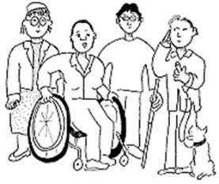 | Safeguarding is protecting people who can’t protect themselves from abuse. Abuse is when someone does something that is wrong that may harm you. There are different kinds of abuse.
Physical abuse is hurting someone, it is also holding someone down or locking them in a room
Emotional abuse is Saying things to someone to upset them, make them feel embarrassed or threatening them.
Neglect is not meeting the needs of someone you are looking after who is dependent on you.
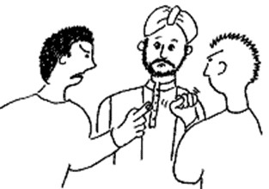 | Discrimination is when someone is nasty or unkind and treats someone differently because they have a disability, are a different colour or religion or because of their age, sex or sexual choice
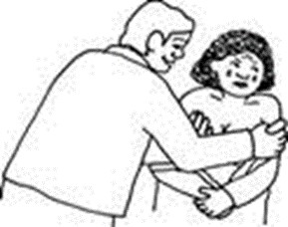 | Sexual abuse is if someone is forced to have sex or asked to touch someone or touched themselves in private areas of their body when they don’t agree.
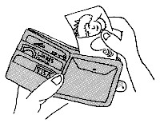 | Financial abuse is when someone steals money or property or persuades someone to pay for things or lend them money or items when they don’t want to.
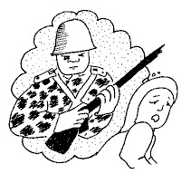 | Radicalisation is Persuading people to become involved in terrorism.

If you think you are being abused or someone you know is please tell your tutor.
If you have any concerns, or someone has disclosed abuse to you, speak to your tutor, ask to speak to another member of ACL staff or contact the ACL Safeguarding Lead Jill Newton on 07788301629 or email: jill.newton2@essex.gov.uk

