Adult Community Learning
Learner Handbook Summary
Information and Advice

We offer free and confidential
information, advice and guidance to all learners.

Information given will be easy to read.

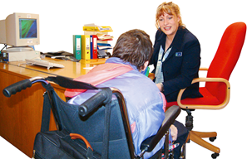 | Learning Support  Please tell us if you have a disability or any difficulties.  There may be some support we can offer you to help with your learning.
Diversity and Equality

We treat everyone with respect no matter how different they are.

We provide equal access to our services for everyone.
Safeguarding and Prevent

We will support you if you are feeling scared or worried about how someone treats you or if someone is trying to change your views.

Please speak to someone if you are worried or do not feel safe.

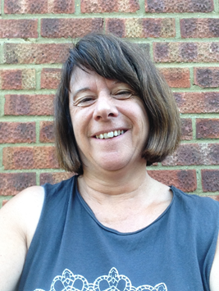 | You can speak to your tutor or the person in charge of Safeguarding and Prevent is Jill Newton.  You can speak to Jill by calling 07788301629 or email jill.newton2@essex.gov.uk
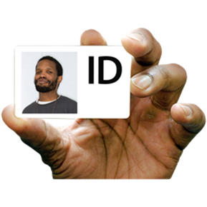 | ID Badges  Please wear your ID badge while you are in our centre, this is about keeping everybody safe.
Harassment

This means we do not accept bullying or bad treatment in any way.

Mobile phones

Please switch off your mobile phones during the lessons unless you have an agreement with your tutor.

Noise

Please keep noise to a minimum, especially if signs show there is an exam taking place.

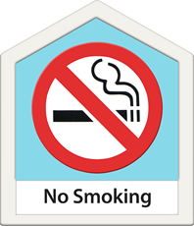 | No Smoking  No smoking inside any of our buildings or at the entrance to any of our buildings.
Bad Weather

If classes are closed due to bad weather we will make every effort to contact you.

Electrical Equipment and Computers

Please use electrical equipment safely.

Fire Safety

If the fire bell rings, please leave the building immediately and go to the fire assembly point.

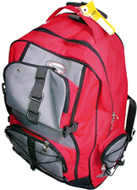 | Personal Property  Please look after your things when you are at college.  We are not responsible for any lost or damaged property.
Complaints and Compliments

Please tell us when we do things right.

Please tell us what we could do better.

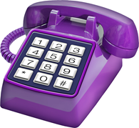 | How to contact us:  Telephone: 0345 603 7635
 | Internet: www.essex.gov.uk/adult learning

