Finding your way around your course

Once you are in your course area, you will find resources your tutor has uploaded.
There are pages which will open up on the screen
There are links to external web pages and videos
There are Word documents or Powerpoints which you can download to your computer

Your tutor may want you to upload assignments or pieces of work. Click on the link 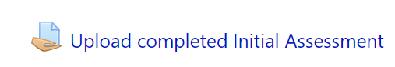
Click add submission 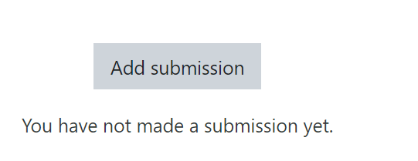
You can then add online text or search for a file from your computer and upload it.

