Accessing Your VLE Account

Once you are logged into the VLE you will see any courses you are enrolled in on the left hand side.
Click log in.
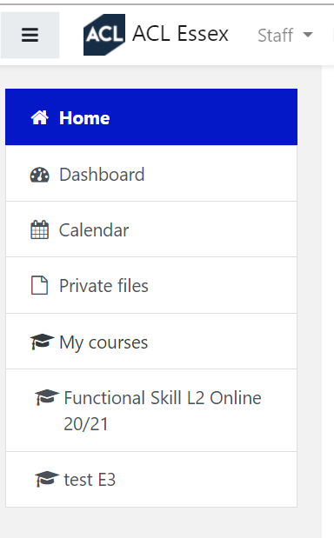
Click on the course you wish to access.
If your course has a live lesson you will see this symbol Click to enter.
If you are there before your tutor, you will be asked to wait for a moderator.
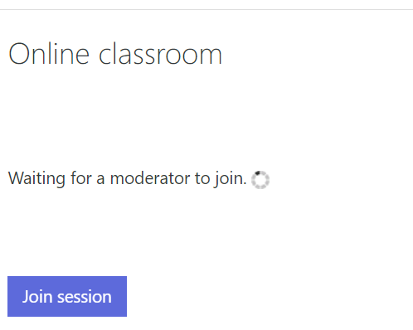
Once the tutor is there, you will be able to click on ‘join session’

You will be asked how you wish to join the session – click on the microphone so you can join in.
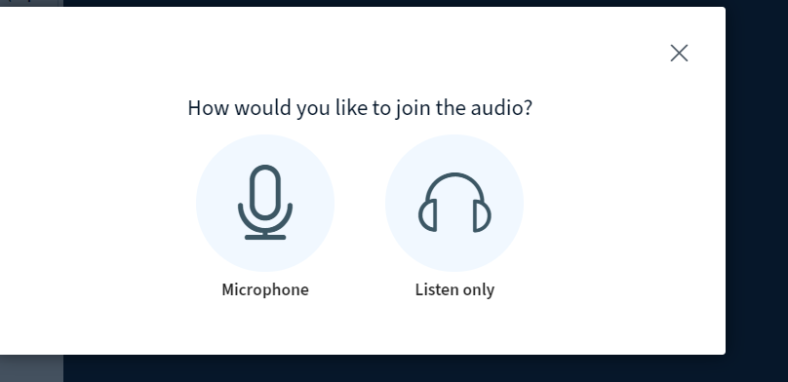
You can now post in the chat, turn on your web cam and join in your lesson.

