Class NoteBook – Apple devices

To access Class NoteBook you will need to have downloaded the OneNote app to your device.

Click on your Team and click on the General channel
Here you can see any posts, files and click More here you will see assignments and also Class NoteBook

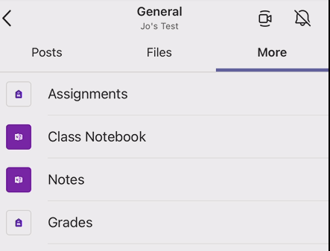
Click and this will take you to your NoteBook. You can now see all the sections and open them to add any information or files.
