Exclusion Policy

Control of documents: Adult Community Learning Senior Leadership Team

Policy aims and intention

This policy seeks to make clear the circumstances in which a learner may be excluded from the learning provision. It seeks to ensure that learners take responsibility for their own actions and/or behaviours.

The Exclusion Policy is considered when all possible actions identified through the Fitness to Learn Policy have been exhausted or the serious nature of the behaviour being addressed requires investigation without possible interference or is likely to impact upon the safety of the individual or others in the College.

The Service will ensure a mechanism is in place which supports a process of graduated warnings. In the most serious circumstances exclusion may be instantaneous at the discretion of the Principal or Vice Principal. An appeals process will also be implemented.

Responsibility group Senior Leadership Team

Policy Writer Safeguarding and EDI Lead

Date of acceptance 16th March 2010

Last review date August 2020

Next review date August 2022

Audience All Managers, academic and support staff, volunteers,
Learners, and other service users.

The policy

For the purpose of this document the use of the term learner is inclusive of apprentices.

The Adult Community Learning Exclusion Policy operates within two contracts, the Learning Agreement and the ACL Charter. The former is a legal contract signifying that the learner is eligible for Skills Funding Agency and Education Agency funding. The latter is a social contract which defines a set of behaviours the Adult Community Learning Service expects learners to comply with.
In addition, the exclusion policy will operate in circumstances where Awarding Organisations regulations are contravened.

ACL is committed to the fair treatment of all learners; therefore, whenever possible learners will receive a maximum of two verbal warnings and/or two written warnings prior to exclusion, dependant upon the severity of the misdemeanour.
Exceptions may apply if a learner behaves in a way that others might consider unacceptable due to having a disability where a reasonable adjustment needs to be made. For example, a learner who is autistic may break rules without realising it or because they are anxious or stressed if their needs are not being met. Any decisions made will take into consideration the Equality Act 2010 and ensure that no direct or Indirect discrimination takes place when a learner has a disability. In some cases, this may mean a more proportionate response such as:
- making reasonable adjustments and providing extra support
- helping a learner to manage and reduce anxiety and stress
- encouraging good relationships with other learners
- making sure that learning and wellbeing needs are met
Instances of serious misconduct necessitating immediate exclusion are listed below and will be at the discretion of the Principal or Vice Principal, and in certain instances this responsibility may be delegated to an appropriate member of the Leadership Team.

Definitions

Minor misdemeanours
Any deliberate action that adversely affects the ability of other learners to learn and/or staff to carry out their duties/roles in a safe and secure environment, such as:

- Use of inappropriate/bad language
- Being under the influence of alcohol or substance misuse
- Disregard of emergency evacuation procedures
- Plagiarism and/or cheating
- Behaviour that is disruptive to staff/other learners

Unwritten, yet reasonable, sanctions are in place for adult learners who may be significantly disrupting the learning of others. If an incident is deemed to cause significant disruption, action may be taken by the member of staff dealing with the incident; this can be a member of the teaching, assessing and or front-line staff, who may ask a learner to leave the classroom, centre or training session, but does not currently constitute a formal exclusion.

COVID-19

Whilst using our centres it is an expectation that all learners will abide by the rules to keep themselves and others safe from the risk of infection. If it is deemed that a learner is not complying with the rules, due to either not understanding them or being unwilling to follow them and is therefore putting themselves and others at risk, then it may be necessary to ask them to leave the centre and not attend for the period of time the risk remains in place. This will not be a formal exclusion and alternative ways of them continuing with their learning will be explored.

Discriminatory behaviour

- Offensive language, particularly relating to Race; disability; gender; gender reassignment / transgender status; age; sexual orientation; religion or belief;

pregnancy / maternity; marriage or civil partnership, including inappropriate jokes, e-mails or other communication tools
- Refusing to work with another learner when required as part of learning programme, for reasons relating to the above strands.

Serious misconduct
Which will result in immediate exclusion includes:

- Threatened and/or actual verbal, physical or sexual abuse within ACL premises
- Fraudulent claims for funding/fee remissions
- Theft and/or misuse of property
- Misuse of ILT (Information Learning Technology), including, but not exclusively, viewing and/or downloading or passing on of illegal material
- Other deliberate unacceptable behaviour which results in injury to others and/or damage to property
- Any illegal activity, such as supplying illegal substances within ACL premises or grounds, carrying offensive weapons etc
- Intentionally bringing ACL or the locality/centre into disrepute

This list of examples is not exhaustive but is indicative of the severity of such offences and the fact that such behaviour can affect the well-being of the ACL community and therefore will not be tolerated.

Where appropriate and required serious misconduct will be reported to the police.

Method of Implementation

All exclusions are treated in the strictest confidence. Only those who need to know the details of exclusion should be informed of them.

Types of Exclusion:

Learners can be excluded from ACL in two ways:
- Suspension or fixed term exclusion
- Permanent exclusion.

Suspension / Fixed term exclusions

Suspension/ fixed term exclusion can only be decided by the Principal, Vice Principal or the Safeguarding Lead together with a Curriculum Lead.
Suspension or fixed term exclusion is not intended to correct learner behaviour. This process will only be used when:
- Health and safety is compromised where a learner’s presence is believed to be a risk to themselves or others, i.e. breaking rules that affect their safety and others.
- To allow an investigation to take place following a serious incident where the learner’s presence may affect the procedure, such as an accusation of abuse.

Responsibilities

Every member of the ACL Community has certain responsibilities, whether staff or learners:

Learners

- To have an awareness of what constitutes behaviour which may lead to exclusion
- To make a commitment to not behave in a manner which could lead to exclusion

Tutors, managers and other staff

- To lead by example by displaying appropriate behaviour
- For ensuring that all learners are familiar with the requirements of the Learning Agreement and the ACL Charter
- For ensuring standards of conduct which comply with ACL Policies and Statements
- To challenge behaviour which could lead to exclusion
Providing adequate support in respect of appeals ensuring a proper investigation
- Providing adequate support during the appeals process

Method of implementation

- It is essential that learners are made aware of the contractual requirements of the Learning Agreement and ACL Charter and of the expectations placed upon them by the ACL Service.
- Procedures for dealing with incidents leading to, or which have the potential to lead to exclusion are clear and transparent, following a designated process which records warnings given, plus other support evidence as appropriate:

- Allegations against learner reported to manager and recorded on incident form E1
- Witnesses to incident asked to provide statements
- Depending on the seriousness of the incident, temporary suspension may be put in place pending investigation
- Thorough investigation takes place, which includes an opportunity for the learner to give his/her version of events. Consideration also needs to be given to whether any incident was provoked, for example by bullying, racial or sexual harassment.
- Judgment made as to whether circumstances dictate consideration of exclusion from ACL provision; others may be consulted at this stage, however not anyone who may later be involved in reviewing a decision
- Decision to exclude a learner will always be made by a panel. The panel may require that it is a virtual panel and will consist of a minimum of 3 senior managers, which may include relevant members of the Extended Leadership Team. (Form E3). A specific period of exclusion time will be determined by the panel; it will then be determined how long the exclusion should last based on the severity of the incident:

- The remainder of the term – after which the learner may return to ACL provision following a reintegration meeting
- The remainder of the academic year – after which the learner may return to ACL provision following a reintegration meeting
- Permanently (Form E2)
- Learner informed of Notice to Exclude and Right of Appeal
- In the first instance Appeals will be made to the ACL Vice Principal.
- In the event that a learner does not accept the decision a final appeal may be made to the ACL Principle.

Minor misdemeanours will be given a verbal warning, if persistent will either be followed by a 2nd verbal warning a written warning or an exclusion dependant on the severity of the behaviour.

Discriminatory behaviour as defined by Equality legislation will be given a written warning, if persistent followed by either a 2nd written warning or exclusion.

In the case of serious misconduct exclusion may be immediate

Violent People Warning Markers Procedure

ACL will follow ECC’s procedures regarding putting a risk of violence marker on our records, this will apply in the following, (definition provided by the Health and Safety Executive) ‘Any incident in which a person is abused, threatened or assaulted in circumstances relating to their work’.

The aim of a marker is to help alert staff to individuals who pose or could pose a risk of violence and enable them to reduce this risk. https://intranet.essex.gov.uk/Documents/Violent_people_warning_markers_procedure.pdf

Monitoring and evaluating

- Records of warnings given
- Records of supporting evidence
- Records of actions taken
- Records of Exclusions
- Records of Appeals

A senior member of the ACL panel will be allocated the responsibility for monitoring the progress of the investigation and subsequent action. All records will be treated as confidential and stored in accordance with the General Data Protection Regulation (GDPR) 2018.

Related Policies

- Adult Safeguarding Policy
- Children and Young People Safeguarding Policy
- Disability Policy
- Fitness to Learn Policy
- Equality and Diversity Policy
- ECC Violent People Warning Markers Procedure

At the time of writing every effort has been made to address potential issues which may lead to exclusion; however ACL Essex reserve the right to assess each situation according to Service requirements and make decisions based on individual circumstances.

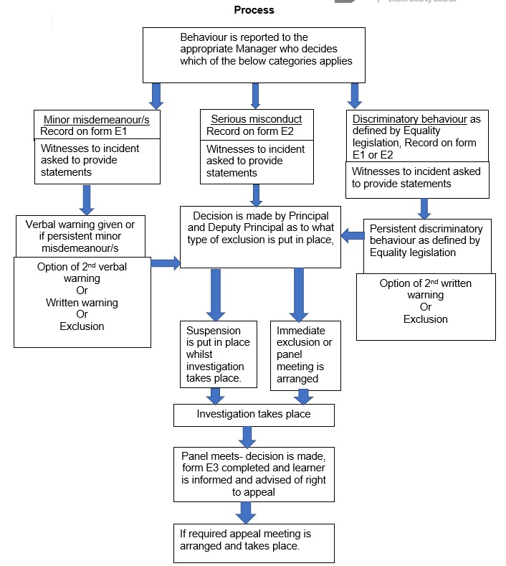

Process

(Accessible version of the flowchart on previous page)

- Behaviour is reported to the appropriate Manager who decides which of the below categories applies.

- Minor misdemeanour/s - Record on form E1,
- Serious misconduct - Record on form E2
- Discriminatory behaviour as defined by Equality legislation, Record on form E1 or E2

- In all cases witnesses must then be asked to provide statements

- Following action:

- Minor misdemeanours - Verbal warning given or if persistent minor misdemeanour/s Option of 2nd verbal warning or Written warning or exclusion – if exclusion decision is made by Principal and Deputy Principal as to what type of exclusion is put in place
- Serious misconduct Decision is made by Principal and Deputy Principal as to what type of exclusion is put in place -
- Discriminatory behaviour Persistent discriminatory behaviour as defined by Equality legislation - Option of 2nd written warning or exclusion – if exclusion decision is made by Principal and Deputy Principal as to what type of exclusion is put in place.

Principal or Deputy decide whether Suspension is put in place whilst investigation takes place or an Immediate exclusion. Both decisions will be followed by:

- An investigation takes place
- Panel meets- decision is made, form E3 completed and learner is informed and advised of right to appeal
- If learner appeals, appeal meeting is arranged and takes place.

Appendix 1

E1 - Minor Misdemeanour Form – to be completed by relevant Manager

Learner: Learner Number:

Contact Information:

Details to be taken from the learning agreement: (if known / available)

Age: Disability:

Gender: Religion:

Ethnicity: Learner Sexual orientation:

Has the learning provider made reasonable adjustments to account for any of the declared information detailed above? Please give details:

Manager’s name, Job title and contact details:

Details of misdemeanour:

Justification as to why action is being taken:

Could the misdemeanour have been lessoned if reasonable adjustment had been made by the learning provider on the grounds of a disability or other protected characteristic?

Action Taken: when: by who: in liaison with:

Follow up date:

Signed: Dated:

This form is to be stored in accordance with GDPR.

Appendix 2

E2 Permanent Exclusion Form – to be completed by relevant Manager.

Learner: Learner Number:

Contact Information:

Details to be taken from the learning agreement: (if known / available)

Age: Disability:

Gender: Religion:

Ethnicity: Learner Sexual orientation:

Has the learning provider made reasonable adjustments to account for any of the declared information detailed above? Please give details:

Designated manager’s name, Job title and contact details:

Details of Gross Misconduct:

Justification as to why action is being taken:

Could the misconduct have been lessoned if reasonable adjustment had been made by the learning provider on the grounds of a disability or other protected characteristic?

Action Taken: when: by whom: in liaison with:

Sanctions imposed:

Follow up date:

Follow up action to be made by:

Signed: Dated:

This form is to be stored in accordance with GDPR.

Appendix 3

E3 Exclusion Panel Consultation Form – to be completed by relevant Manager.

Learner: Learner Number:

Contact Information:

Details to be taken from the learning agreement: (if known / available)

Age: Disability:

Gender: Religion:

Ethnicity: Learner Sexual orientation:

Has the learning provider made reasonable adjustments to account for any of the declared information detailed above? Please give details:

Details of relevant mangers on the panel (name, Job title, contact details)

Details of events leading up to the panels meeting: List details of all reported / recorded misdemeanours and actions of gross misconduct.

Justification as to why action is being taken:

Could the misconduct have been lessoned if reasonable adjustment had been made by the learning provider on the grounds of a disability or other protected characteristic?

Sanctions to be imposed:

Actions to be taken by the panel:

Follow up date and actions:

Signed: Dated:

This form is to be stored in accordance with GDPR

Appendix 4

E4

Example letter notifying learner of exclusion / sanctions being put in place:

Dear Learner,

I am writing to you following an incident (series of incidents) that took place on xxxxxxxxxx, at xxxxxxxxxxxxxxxxx.

Adult Community Learning cannot accept or justify your actions and the sanctions we intend to impose are xxxxxxxxxxxxxxxxxxxxx (or please accept this letter as a formal warning)

If you wish, you may appeal against the decision to me, setting out your reasons,

Yours sincerely,

Vice Principal

