Admissions Policy

Control of documents: Adult Community Learning Senior Leadership Team

Policy aims and intention

ACL is committed to offering an admissions process which ensures equality of opportunity for all prospective learners and supports them to:

- investigate available opportunities for study which are appropriate to their abilities and aspirations.
- discuss their support needs.
- make informed decisions about enrolment and progression opportunities available to them.
- be successful on their chosen course of study.

ACL respects the privacy of individuals and maintains appropriate confidentiality to complete the admissions process, except where there is clear evidence of serious risk to the applicant or welfare of others.

Responsibility group Senior Leadership Team

Policy Writer Safeguarding and EDI Lead

Date of acceptance
Last review date January 2020

Next review date January 2021

Audience All Managers, academic and support staff, volunteers,
Learners, and other service users.

The policy

For the purpose of this document the use of the term learner is inclusive of apprentices.

Legislation

The following legislation applies to this policy:

▪ The Rehabilitation of Offenders Act 1974

▪ Equality Act 2010

▪ Data Protection Act 1998

▪ Education Act 2011

Method of Implementation:

Enrolment

- Offers of places and enrolments are made on the basis of there being sufficient demand for the course and there being sufficient spaces available on the course concerned.
- Where a place being offered is on an apprenticeship programme, as well as meeting the academic entry criteria, appropriate employment must be secured to meet the relevant apprenticeship programmes.
- Current Information on eligibility for funding is available on the ACL website.

Additional Learning Support

ACL ensure provision of appropriate support and resources through Additional Learning Support which includes, provision for communication support, learning support assistants (LSA’s), assistive resources and other resources as appropriate within financial capability. Course publicity on the website highlights the Service policy and procedures relating to all aspects of Learning Support, i.e. Additional Learning Support and Discretionary Learner Support, Community Learning Bursary Funding and 19 + Advanced Loan Bursary Fund.

IAG

Adult Community Learning Essex is committed to providing a clear, impartial information and advice service to adults. The IAG service is confidential and client focussed in accordance with the Matrix Framework. Information offers up to date information on learning and career opportunities to support learners with their personal goals without going into significant detail. Advice is where more in-depth information that is tailored and focused on their individual need. Guidance is where the IAG assists clients to comprehensively explore learning or career options and this may include referral to the National Careers Service.

Unsuitability

In the following exceptional cases ACL may refuse an application to join a course:

- If a person is unable to satisfy the formal entry requirements and in all such cases, they will be guided to a more appropriate course with a view to joining their chosen course when they have achieved the qualifications required.

- Has previously been excluded from ACL or another educational institution or has a history of anti-social and/or offending or other behaviours which indicates a safeguarding risk to other members of the ACL community

- Withholds information or provides false and/or misleading information.

- If a person has complex needs that cannot be met by reasonable adjustment, or a history of extreme behaviour which could pose a risk to themselves, other learners and staff then ACL has the right not to allow enrolment. In order to assess this risk and make an informed decision, a risk assessment will be carried out for each individual case.

- Have unspent or pending convictions that will mean other learners and staff may be put at risk. This policy may also be invoked where information is available concerning activities outside the law or the expression of beliefs, which pose a clear and immediate danger of contravention of the law.

- If a programme requires a work placement which needs a successful DBS check e.g. an Early Years Apprenticeship. In the case of information on the DBS showing an unsuitability for the position, enrolment would be declined.

- Has outstanding debts to ACL

Applicants will be asked at the enrolment process to declare if they have a criminal conviction, if they tick this box then they will be contacted and asked to disclose what this is. This information will be treated in confidence and is only required to assist us to fulfil our responsibilities to assess any potential risk to our learners.
A decision will then be made as to whether there is a risk and if so, a risk assessment will be completed with the applicant. In cases where it is considered too great a risk or if a person wishes to enrol on programmes with a practice component leading to professional registration where they are required to demonstrate their fitness to practise, and the conviction will mean this registration is not possible, a decision regarding enrolment will be made by Senior Management.

Appeals

Applicants who wish to appeal against any admissions decision should write to the Principal who will investigate and determine the outcome. Applicants who remain dissatisfied may use the ECC complaints procedure.

Monitoring and evaluating

All records will be treated as confidential and stored in accordance with the General Data Protection Regulation (GDPR) 2018.

Related Policies

- Adult Safeguarding Policy
- Children and Young People Safeguarding Policy
- Disability Policy
- Fitness to Learn Policy
- Equality and Diversity Policy
- Learning Support Policy
- Exclusion Policy

Risk Assessment

Risk
An uncertain future event which could adversely affect other learners or staff

Risk Likelihood
It is the probability that a risk can occur. Likelihood can be described as high, medium and low.
High: An event is expected to occur in most circumstances
Medium: An event will probably occur in many circumstances
Low: An event may occur at some time

Risk Impact
It is the potential effect that a risk could have on others if it arises. The magnitude of impact also will be categorized as high, medium and low.
High: Serious impact on others, or effective service delivery
Medium: Significant impact on others, or effective service delivery
Low: Less significant impact on others, or effective service delivery

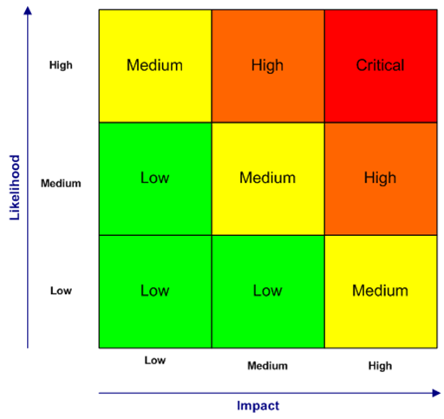

Initial assessment following disclosure

Name

Course applied for

Date of assessment

Name of assessor

Questions that will help better understand the applicants criminal record and its relevance to risks if attending a course

Question

Details provided
Is a disclosure discussion necessary?
Risk: No - Green
Category: Not relevant (e.g. old or minor). Didn’t need to disclose e.g. spent
Explanation:

Is a disclosure discussion necessary?
Risk: Yes - Amber
Category: Potential concerns
Explanation:

Is a disclosure discussion necessary?
Risk: No - Red
Category: Not possible to offer place on course
Explanation:

YOUR RISK MANAGEMENT PLAN

Name:

Date Completed by:

Date of Plan:

RISK | MANAGEMENT PLAN | REMAINING RISK

Review Date: | Your Signature: | Assessors Signature:

