Logging into Teams App – Android devices

Click on the Teams app on your device.
Click to log in – you will only need to do this first time, it will remember you after that.

Enter your ACL email address (firstname.surname@essexacl.ac.uk)
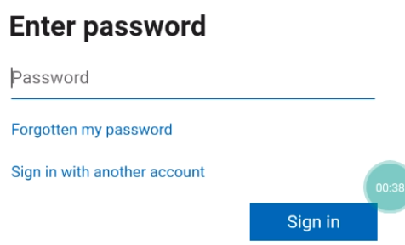 Enter your password and click Sign In
The first time you log in you may see some options. Remember to allow your camera and microphone if asked.
Scroll through the information and click next
Then click Got It
You are now into Teams

