Finding Your Team or class – Apple devices

In your Teams app you will see 5 options.



To access your live class session, click on the calendar picture at the bottom.

Click on the Join button at the right time for your class.

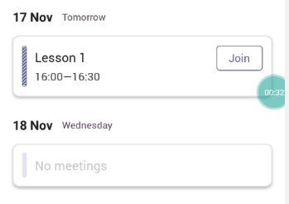

Remember to allow your microphone and camera if asked.

Click join now.

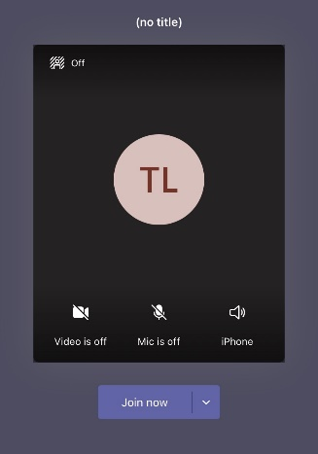

At the top, you will see the chat pane. If it disappears click anywhere on your screen.

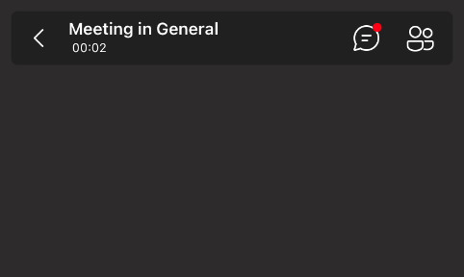

At the bottom of the screen, click on the three dots which will give you different options for during your session.



