Getting the Team App – Android devices

From your phone or tablet, go to the Play Store and type in TEAMS
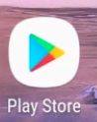
Microsoft Teams is the first App and has a purple icon
Click to install. You may also want to download some other Apps to support your learning such as:
Word 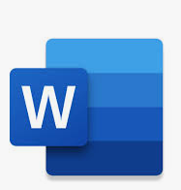
OneNote – this is used for your Class NoteBook 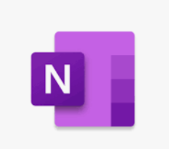
One Drive to help you store and share your files and documents.

