Accessing Teams for Education

Your tutor will let you know whether you are learning through Teams or the VLE.
If you are using Teams you will need to log onto Office.com using your firstname.surname@essexacl.ac.uk log on details.
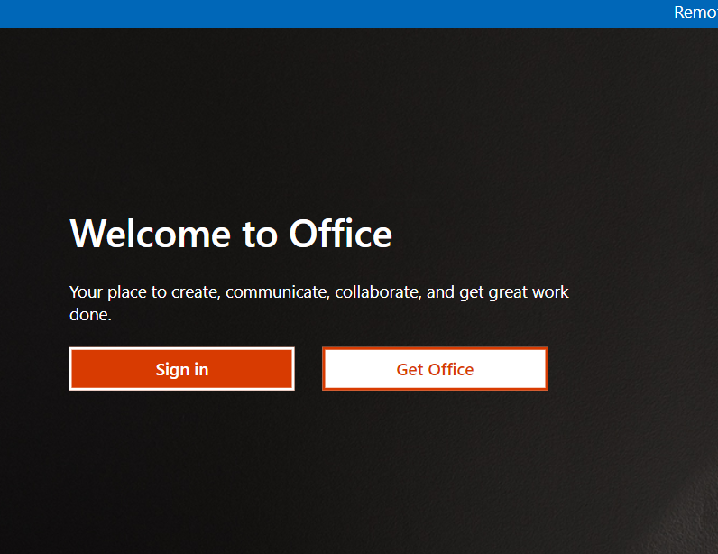

Click on the Teams icon

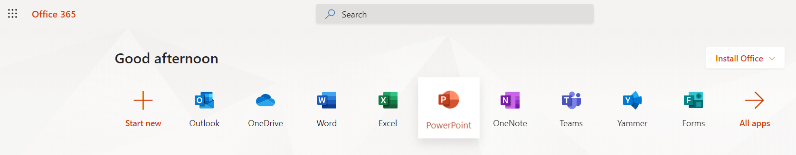

This will show all the Teams you belong to; you may have more than one depending on the number of classes you are studying with us.
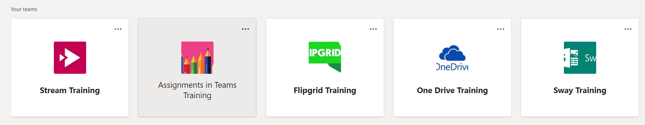
Click on the Team relevant to your class.
There may be different channels here which your tutor will explain to you how they are used.
Please take time to familiarise yourself with the information in the induction channel particularly on Safeguarding and British Values and how to stay safe online

