Accessing your OneDrive

In your browser type in Office.com you will be better using Chrome or Edge as your browser.
You will then see the list of available apps.
Click on OneDrive.
One Drive is your safe, online storage where you can keep all your work which you are able to access at any time on any device.

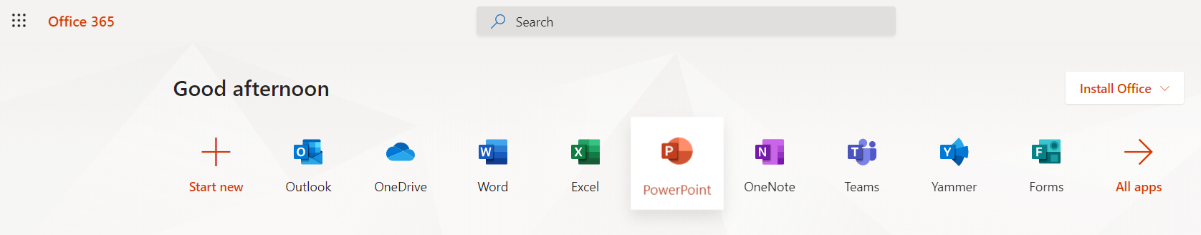

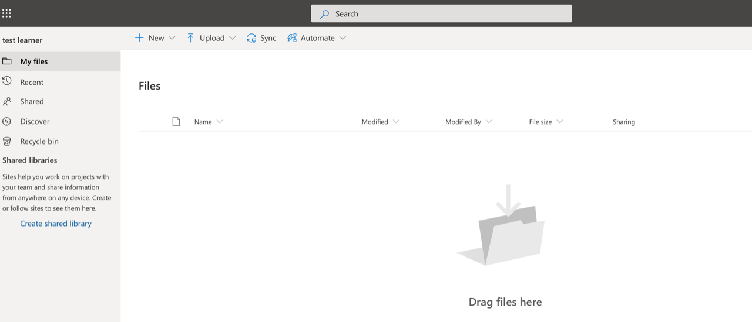
Once you have opened OneDrive you have a few options.

You can upload a document from somewhere else on your computer by clicking on the upload button
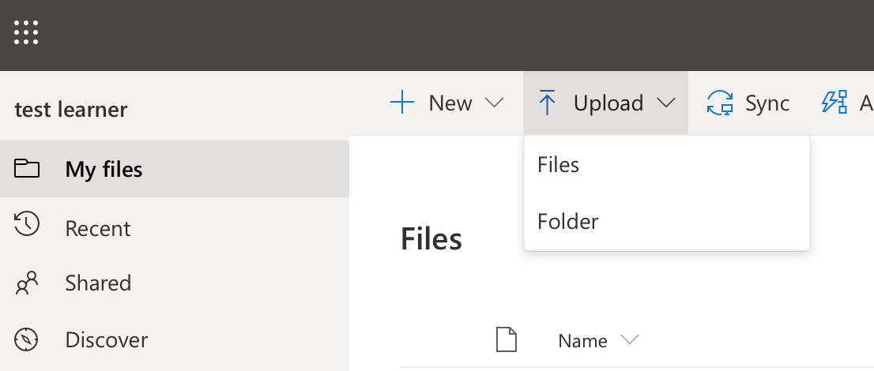

Or you can even create a document directly in OneDrive which will save automatically in there.
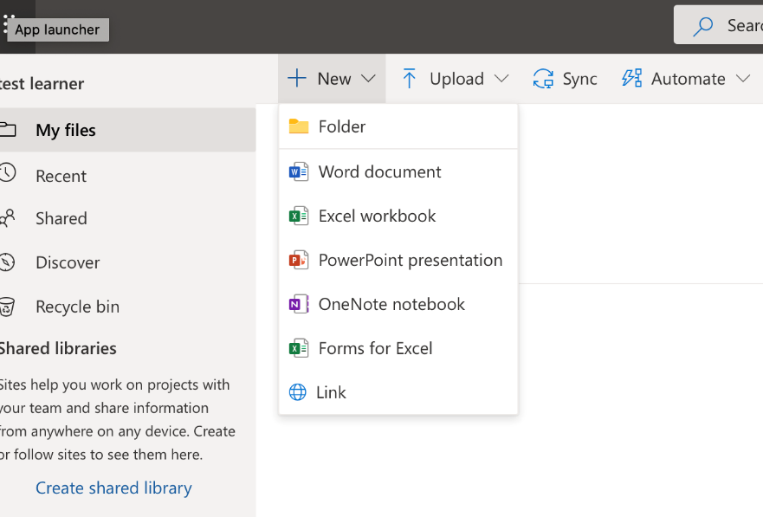
You can also use the new folder to create folders to organise your work in.

You can also share your work directly from OneDrive with your tutor. Click on the three dotes next to the document where you have lots of different options.
Click on ‘share’ and enter your tutor’s details to send to them.
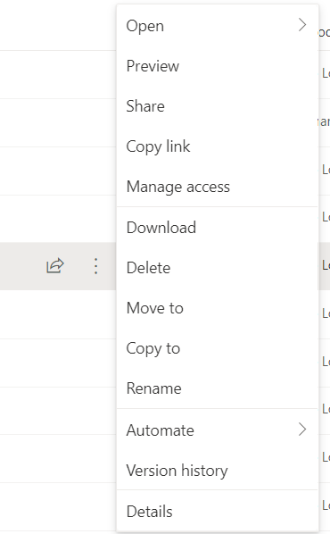

Your account remains active for 2 months after you have completed your learning with ACL.

